**Kathmandu University**

**Department of Computer Science and Engineering**

Dhulikhel, Kavre



A project Proposal

on

**“Car Rental Management System”**

[Code No: 102]

(For partial fulfilment of 1st Year/ 2nd Semester in Computer Engineering)

**Submitted by:**

Rojen Dangol (15)

Hridaya Pradhan (38)

Bigyan Byanju Shrestha (49)

Manish Sunuwar (54)

**Submitted to:**

Ms. Rajani Chulyadyo

Department of Computer Science and Engineering

**Submission Date:** 5th January 2022

# **Abstract**

The car rental management system is a software designed for effective and efficient management of rental processes that are involved during renting of cars. It aims to make the process of renting a car hassle free and also attempts to steer the way data and information is managed in typical rental companies from traditional ledger records to digital records. To make this project come to fruition, we have conducted thorough research on similar programs and have had sessions for brainstorming while collecting resources and tools that we would need in our endeavours. Moreover, we will conduct various experiments with the aforementioned tools to get a better grasp of it and find numerous possibilities in its use, for the betterment of the project. Finally, we plan on using the tools and proceed with the coding of the project while conducting tests and debugging them as we finish the smaller modules of the code and the program as a whole would be debugged at its end. Through this project, we hope to solve the problem of information mis-management and make the process of renting a vehicle as easy and systematic as possible.

**Keywords:** Efficient, Digital records, Information management, management system.

**Table of Contents**

Abstract i

List of Figures iii

Acronyms /Abbreviation iv

Chapter 1: Introduction 1

1.1 Background 1

1.2 Objectives 2

1.3 Motivation and Significance 2

Chapter 2: Related Works/ Existing Works 4

Chapter 3: Procedure and Methods 5

3.1 Methodology 5

3.1.1 Research: 5

3.1.2 Brainstorming: 5

3.1.3 Collection of resources and tools: 5

3.1.4 Experimentation: 5

3.1.5 Coding, testing and debugging: 5

Chapter 4: System Requirement Specification 8

4.1 Software Specification 8

4.2 Hardware Specification 8

Chapter 5: Project Planning and Scheduling 9

5.1 Project Planning and Scheduling 9

5.1.1 Planning and Preparation 9

5.1.2 Problem Identification and Requirement Analysis 10

5.1.3 Work Division 10

5.1.4 Coding 10

5.1.5 Testing and Debugging 10

5.1.6 Documentation 11

5.2 Gantt Chart 11

APPENDIX 12

References 13

# **List of Figures**

Figure 3.2 1 Flowchart of the Car Rental Management System 5

Figure 5.2 1 Gantt Chart for Project timeline (Span: 29/12/2021 to 05/03/2022, 12 Weeks Estimation) 8

# **Acronyms /Abbreviation**

CPU: Central Processing Unit  
UI: User Interface  
GCC: GNU Compiler Collection   
pc: Personal Computer

# **Introduction**

With the widespread custom of car rental, this project attempts to simplify and optimize information management in the process of renting cars. It tries to make the process of renting cars transparent and helps an enterprise save its resources while boosting efficiency. Thus, this project is titled Car Rental Management System.

# **Background**

The prevalence of the system of rental vehicles can be seen from the early 90s till this date. It has evolved from renting bicycles to cars and now to even ships and helicopters. Along with the commodity being rented out, the system in which they are being rented has undergone major transformation. In this digitalized age, rather than traditional ways of information being stored in a physical manner, they are stored digitally making it easily accessible. Similarly, in the car rental scenario many companies have adopted this form of digitalization of their system of operation.

In the context of Nepal, it too has been influenced by the wave of digitization and many companies have adapted to it. However, the majority still follow traditional ways. Digital management of car renting can not only save financial resources but also manpower. A well managed system can help an enterprise achieve optimal efficiency and can help in generating more profit, keeping track of its consumers/customers. The available fleets of cars can be easily managed, thus making it simpler in tracking the vehicle's availability status along with the customer’s credentials renting the aforementioned car. Such information becomes vital in business as the company then clearly shows the availability of the vehicles to the consumers. Additionally, advanced booking of the cars can be done easily with less errors as the company can be on track of the vehicles in use and its future availability.

The digitally stored data can be archived in a hassle-free manner and can be accessed at any point in the future without fear of the data being damaged by physical conditions. In contrast to it, the traditional way of storing data has many flaws and drawbacks. Firstly, they have to be stored in a space, specially allocated for it, which would use the available space of the enterprise. Not only that, the management of the aforementioned space would become a liability to the enterprise as they can be easily influenced by physical conditions such as fire, water, and so on. Finally, it is a monumental task to keep those records in an orderly fashion and retrieve the records after a certain period of time for its effective utilization. For instance, it would be an easy task to manage a small number of records, but over the years, the records would stack up to a humongous number taking up more space, more resources to manage it and also would hinder its effective analysis in the future. With the passing of time, such records stored in ledgers would be aged, making them extremely fragile and prone to wear and tear.

The software for management of the data is immensely crucial, thus the coding and its debugging must be done meticulously, trying to avoid any errors that might occur in the future.

# **Objectives**

Car Rental Management System has been chosen as our project with following objectives:

* 1. To make the rental system hassle free and convenient.
  2. To reduce the manual work of booking, accounting and managing
  3. To track the details of the customers and the cars rented
  4. To maintain transparency in the business, making the relationship between the business and its customer sound.

# **Motivation and Significance**

Our project aims to remove the non-transparent and inconvenient system of travelling due to its unspecified costs mainly during domestic tourism. For instance, if a person decides to visit Pokhara, first he will need to take a tourist bus or a flight to Pokhara which is the only part which may be transparent in its costs but the costs for commuting to different sites inside Pokhara are inconsistent and non-transparent. He will either have to take a taxi every time which would be inconvenient or he will have to hire a driver with a vehicle which would have a variable price making it non-transparent. Our project tries to solve this problem by encouraging small and medium scale vehicle renting business which still uses inconvenient hard copy system for managing their business by doing most of the simple works for them like searching for vehicles available for rent, customer info and more with less manpower, so that they can focus on other parts of their business. It would also help the customers as transparency can be maintained. It makes travelling convenient for the customers because they can have privacy and freedom to go anywhere, they want with their friends and family and have a specific budget for travelling costs so they can enjoy their travels to the fullest.

Even if we have gone to a digital age where we can rent a vehicle online, people refuse to use it because they feel unsure and unsafe using a virtually existing business. People feel comfortable using a physically existing business which has offices they can go to for inquiry. Our project aims to build a system to help those businesses with cheap costs so that they can provide quality service.

# **Related Works/ Existing Works**

Having promising prospects, car rental has been integrated in business portfolios, especially travel and tourism, over the past decades. Same trend can be seen here in Nepal. Local business aside, many international rent-a-car companies have been operating in major cities. 

Europcar (Europcar, n.a), a French car rental company, has been actively operating in Kathmandu. It has been working by direct booking via its own website. For booking, we need to have an account of Europcar. 

Smile Car Rental (nepalvehiclerental, n.a) is a Nepalese car rental company. It has been providing its services for major tourist spots and cities. Like Europcar, it has been working by direct booking. For booking, one needs to contact the head office.

SIXT SE (Wikipedia, 2021), a German automotive group, has been providing its car rental service in Nepal. Unlike the above rental companies, SIXT Car Rental uses an indirect booking system. It uses Expedia (Expediagroup.inc, 2021), a third-party travel site, for booking the car.

Our project focuses on shifting the car rental management from hand journal to electronics through direct booking system. However, it does not have the feature of cloud storage, cross-platform application and is only limited to admin pc.

# **Procedure and Methods**

1. **Methodology**The procedures and methods that were followed are described below:

**3.1.1 Research:**   
We will review similar programs, source codes, videos, etc. and their features. Different samples will be taken in account for better design and features.

# **3.1.2 Brainstorming:**

Different ideas and features will be discussed, which can be added in our project later on, while taking account of the resources and tools we have at our hand to provide a productive project. This area will heavily focus on mind-mapping, creating algorithms, flowchart, etc. to get a clear road map, we will be following.

**3.1.3 Collection of resources and tools:**   
We will gather the required resources and tools through different websites, blog posts, videos, articles, etc. on topics related to source codes, use of different UI development tools, etc.

**3.1.4 Experimentation:**   
After all the procedures mentioned above are completed, we will experiment with the resources, tools and information to get a better understanding of their workings and find different possibilities of how they can be used in our project. This will help to avoid any problems while implementing these tools, resources and information in our project.

**3.1.5 Coding, testing and debugging:**  
We will use the aforementioned tools, resources and information to make our program. These things will be used appropriately in our program so that we can get good results from our program and the majority of the time of the project will be used in coding the program. Testing and debugging of small modules of the program will be done at the same time after its creation and the bigger modules and the whole program will be tested and debugged later after the coding has been completed. Testing and debugging will be done to ensure our program has produced appropriate results.

1. **Flowchart**

Rough estimation of the working of code is described by following flowchart

.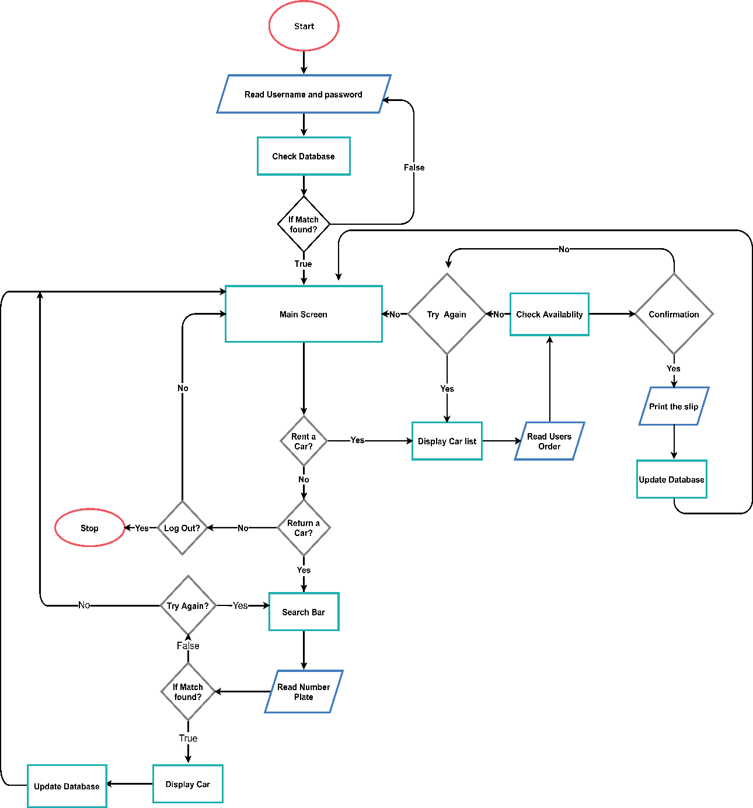

Figure 3.2 1 Flowchart of the Car Rental Management System

# **System Requirement Specification**

* 1. **Software Specification**  
     Our Car Rental Management System supports Linux, Windows, MacOS and any other computer operating system, as long as the program file is compiled for respective operating system. Compilers like GCC, Mingw-w64, Clang can be used for the compilation
  2. **Hardware Specification**  
     The Car Rental Management System can run on any computer. Since our project is not a cross platform, CPU architecture best suited is x86, x86-64, Apple Cortex. Both 64-bit and 32-bit processors can be used.

# **Project Planning and Scheduling**

# **Project Planning and Scheduling**

Considering the work that needs to be learnt and done to complete this project, we have planned to complete our project in 12 weeks. For this purpose, we have divided the entire task into 6 sections which will enable us to work systematically to achieve desired results. The divided sections are as followed:

* 1. Planning and preparation
  2. Problem Identification and Requirement Analysis
  3. Work Division
  4. Coding
  5. Testing and Debugging
  6. Documentation

# **Planning and Preparation**

This marks the beginning of our project. Here, we discussed the topic selection. Every member of the group presented their ideas with supporting explanations. After going through all the presented ideas, we all agreed on developing a “Car Rental Management System”. The team members were tasked to research on different aspects of the project like background, prevalent management system, feasibility of the software and different approaches to develop the program. We then discussed the features of the program considering our knowledge, available resources and the project deadline. The entire team then worked on to create a rough sketch of the whole project which will help us with proposal writing and also development of the program. At the same time, we started taking different courses as we were new to C++ and other tools required for the project. This stage took us about a week to proceed to the next step of the plan.

# **Problem Identification and Requirement Analysis**

In this stage, we will do thorough research on the existing platforms and systems similar to ours which will overcome the drawbacks of the existing ones and will also be more enhanced than them. Similarly, to develop the program, we will need sound knowledge of programming languages, framework development platforms. So, we will also consider the possible challenges we might face while learning for the project as well as doing the project. We have allocated a week for completing this stage, so that we can identify the possible problem and draw possible solutions for them.

# **Work Division**

After developing a road map for the project. We divided the entire task into 4 sections and assigned each section to the 4 team members. This will help in ensuring equal effort from all the team members and also ensure equal learning opportunity and will also help in time management of the project.

# **Coding**

This stage marks the starting of development of the program. We have allocated maximum weeks for this stage as this stage will determine the performance of our program. Every team member will have to code the assigned part of the project in the given time. We will be constantly reporting to each other about our development in the project and help each other if needed.

# **Testing and Debugging**

After coding work is finished, the developed program will be tested properly to check for any prevalent bugs or other programming problems. The program will be further tested through various self-generated situations to check if it runs properly. The defects and bugs are identified and fixed so that the program runs properly. Since, proper performance of the program determines its quality and efficiency, we have planned allocated 1 week testing and debugging.

# **Documentation**

The codes are documented in such a way that it is simple to comprehend and handy for future improvement. The output documentation is then updated so that it is readily understood by the intended users and also looks excellent and well-managed in appearance. We have allocated 1 week time for documentation.

# **5.2 Gantt Chart**

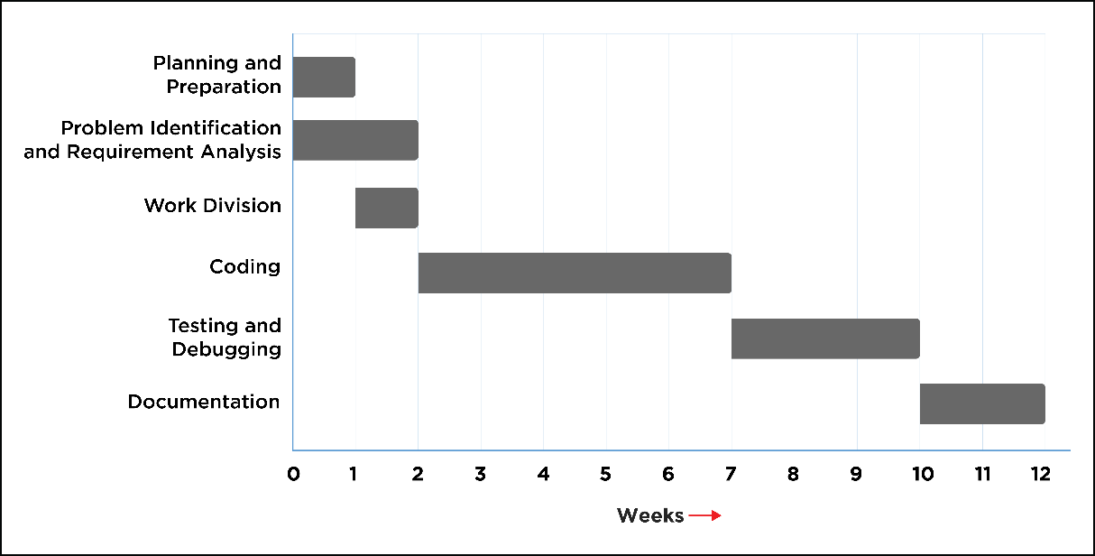Gantt chart has been used as a project management tool for the planning and scheduling of projects, and is particularly useful for scheduling the future tasks in advance. Figure 5.2.a shows how we will approach our goal.

Figure 5.2 1 Gantt Chart for Project timeline (Span: 29/12/2021 to 05/03/2022, 12 Weeks Estimation)

# **APPENDIX**

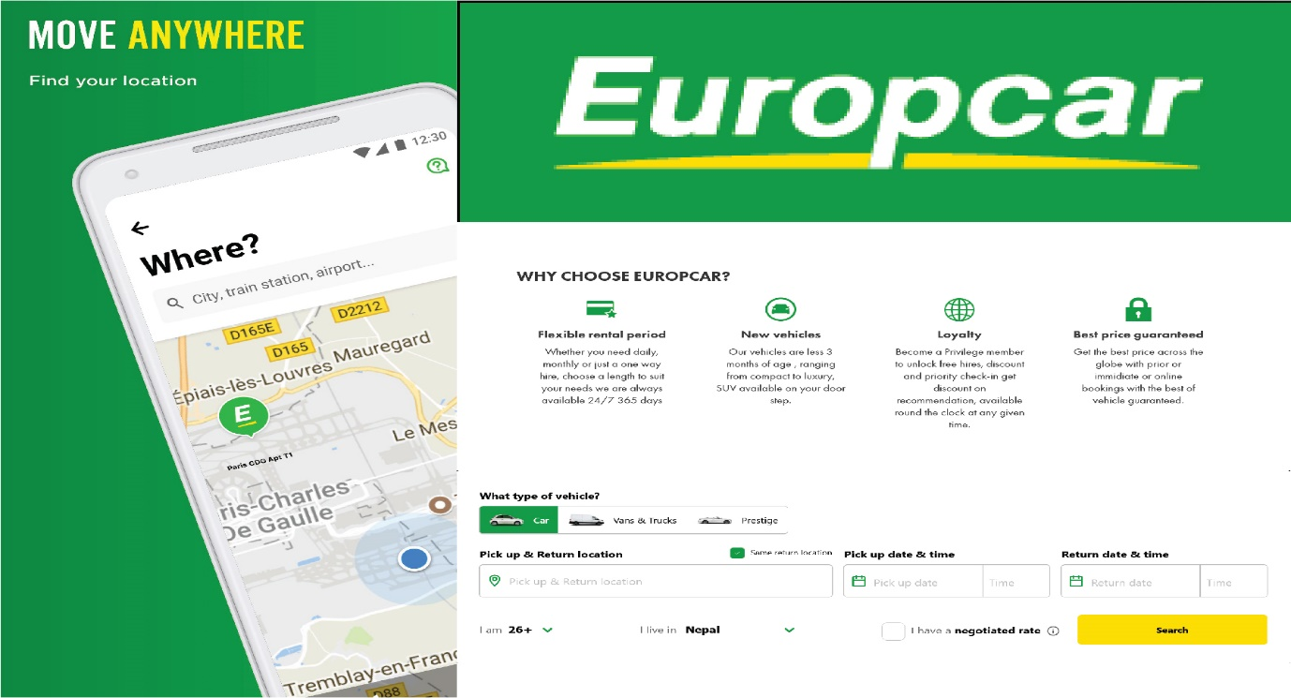Europcar

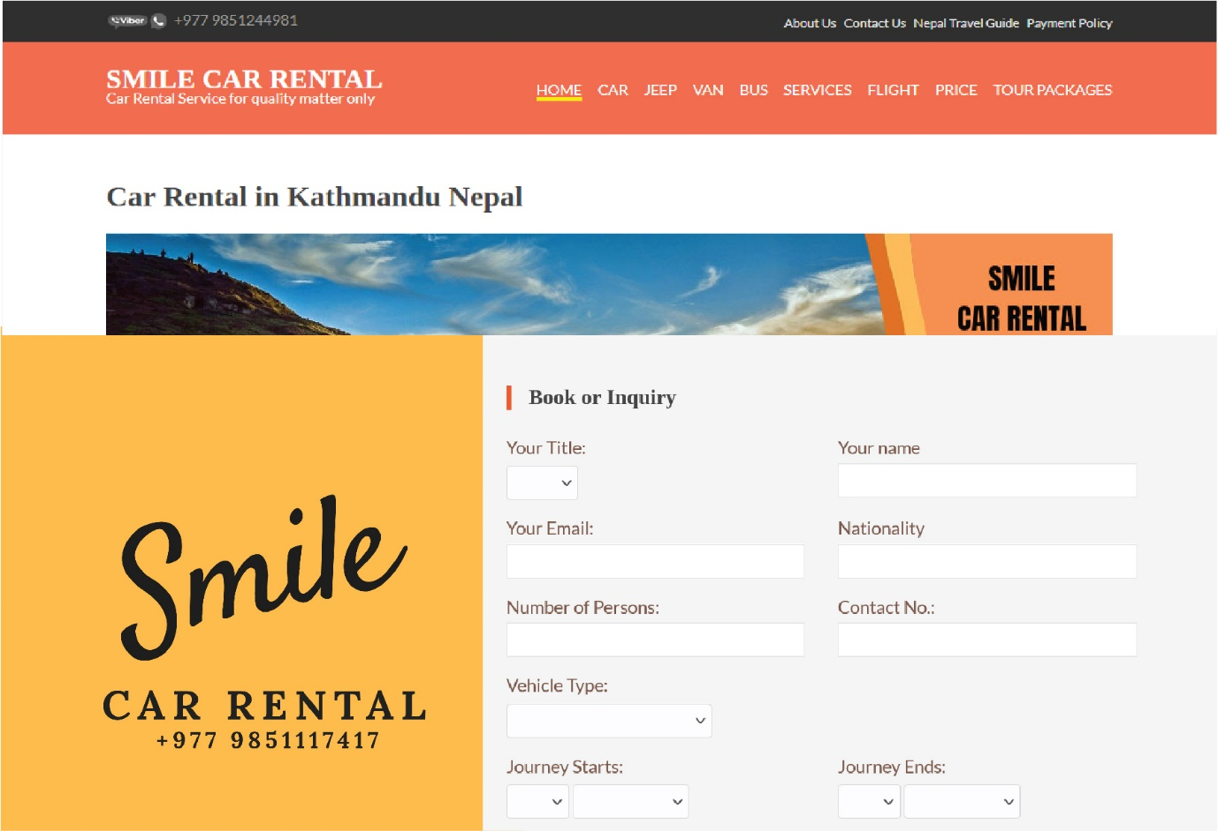Smile Car Rental

# **References**

ArnoldClark, (November 03, 2020). *History of car rentals: What has changed?* Retrieved from <https://www.arnoldclarkrental.com/latest-news/275-history-of-car-rental-what-has-changed>

Europcar (n.d.) *Car Rental in Nepal*. Retrieved from https: //www.europcar.com.np/

moibooblog, (March 6, 2020). *How rental system benefits in increasing the business of rental companies.* Retrieved from <https://www.moiboo.com/blog/how-car-rental-system-benefits-in-increasing-the-business-of-the-rental-companies/>

Expedia, inc. (n.d.) *SIXT car hire in Nepal*. Retrieved from <https://www.expedia.co.in/Sixt-Destinations-In-Nepal.d127-c35.Car-Rental-Destination-Suppliers>

Smile Car Rental (n.d.) *Smile Car Rental Company Nepal Vehicle Rental Company*. Retrieved from <https://nepalvehiclerental.com/>